Min–Max Normalization

Definition
# Source: AI Source: Provided by: [Data Path: Persons Table -> ID Column: 1, Name_En Column: Motasem Essam] -> From: [Chatgpt (GPT‑5 Mini)] on [12/10/2025]
Min–Max Normalization is a data scaling technique that transforms numerical values to a fixed range, usually between 0 and 1. It rescales the original data based on the minimum and maximum values in the dataset.

Formula
# Source: AI Source: Provided by: [Data Path: Persons Table -> ID Column: 1, Name_En Column: Motasem Essam] -> From: [Chatgpt (GPT‑5 Mini)] on [12/10/2025]
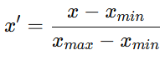
x' = \frac{x - x_{min}}{x_{max} - x_{min}}
Where:
- (x) = original value
- (x_{min}) = minimum value in the dataset
- (x_{max}) = maximum value in the dataset
- (x') = normalized value

How It Works
# Source: AI Source: Provided by: [Data Path: Persons Table -> ID Column: 1, Name_En Column: Motasem Essam] -> From: [Chatgpt (GPT‑5 Mini)] on [12/10/2025]
- Find the minimum value in the dataset.
- Find the maximum value in the dataset.
- Subtract the minimum value from each data point.
- Divide by the range (x_{max} - x_{min}).
This process rescales all values to fall within the 0–1 range.

Example
# Source: AI Source: Provided by: [Data Path: Persons Table -> ID Column: 1, Name_En Column: Motasem Essam] -> From: [Chatgpt (GPT‑5 Mini)] on [12/10/2025]
Original dataset:
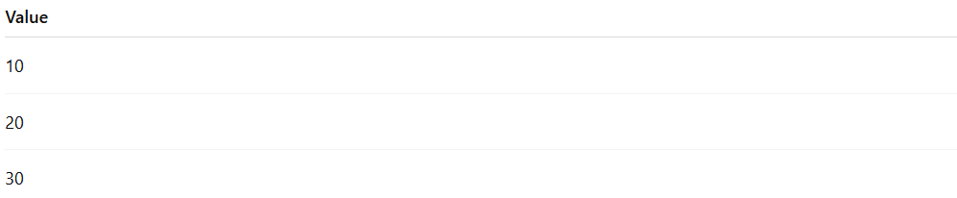
Value
10
20
30
Here:
- (x_{min} = 10)
- (x_{max} = 30)
After normalization:
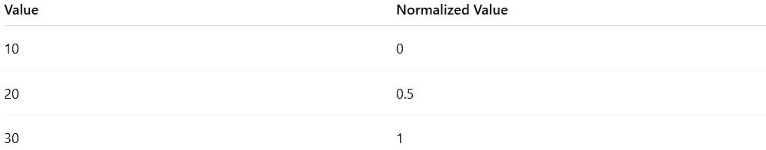
Value | Normalized Value
10 | 0
20 | 0.5
30 | 1

Advantages
# Source: AI Source: Provided by: [Data Path: Persons Table -> ID Column: 1, Name_En Column: Motasem Essam] -> From: [Chatgpt (GPT‑5 Mini)] on [12/10/2025]
- Keeps the relative relationships between values
- Scales data to a consistent range
- Works well with algorithms such as KNN, Neural Networks, and Gradient Descent

Disadvantages
# Source: AI Source: Provided by: [Data Path: Persons Table -> ID Column: 1, Name_En Column: Motasem Essam] -> From: [Chatgpt (GPT‑5 Mini)] on [12/10/2025]
- Sensitive to outliers (extreme values affect scaling)
- If new data exceeds the original range, re-scaling may be required

